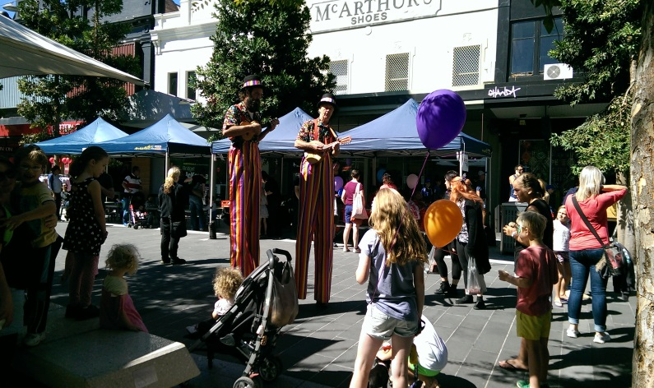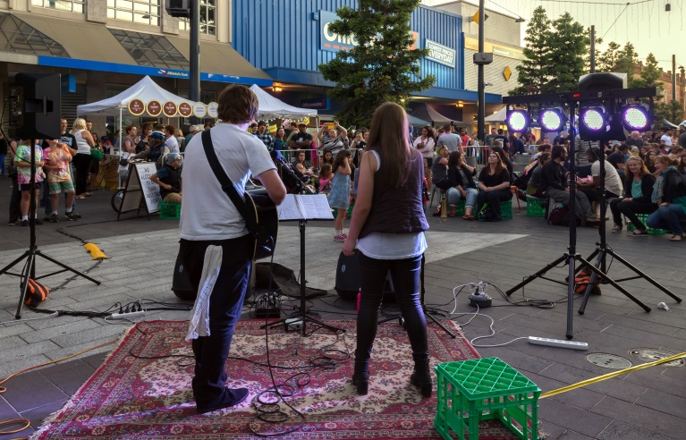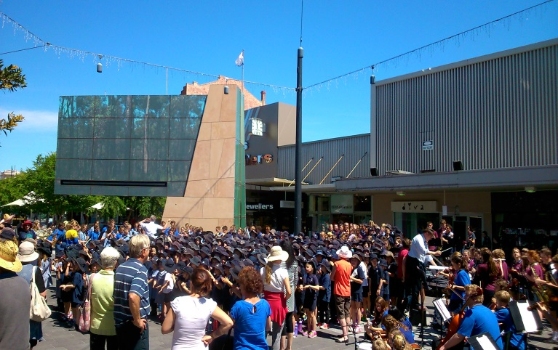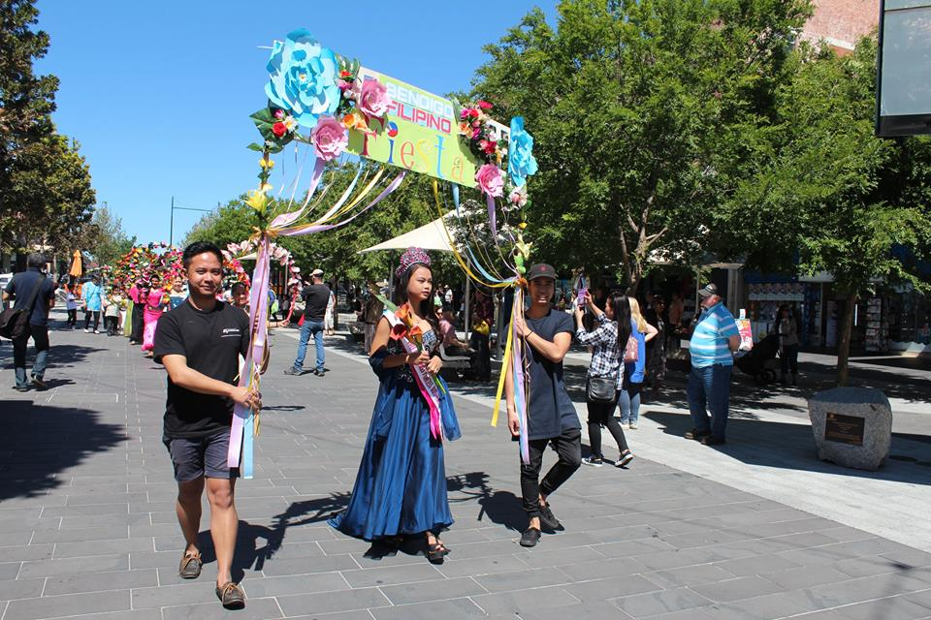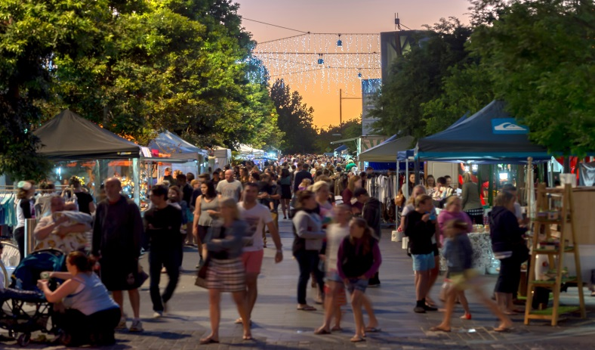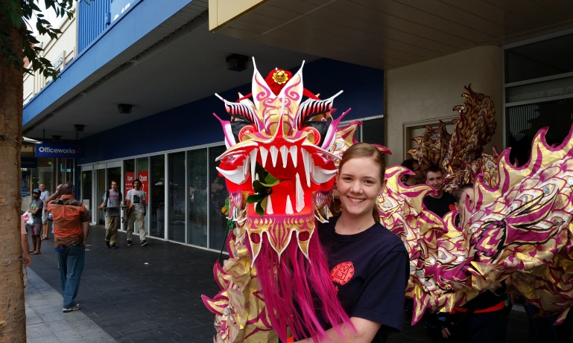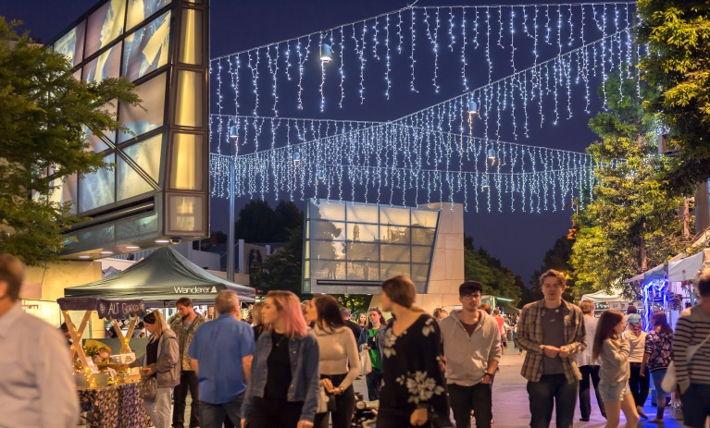

**Hargreaves Mall User Guidelines**

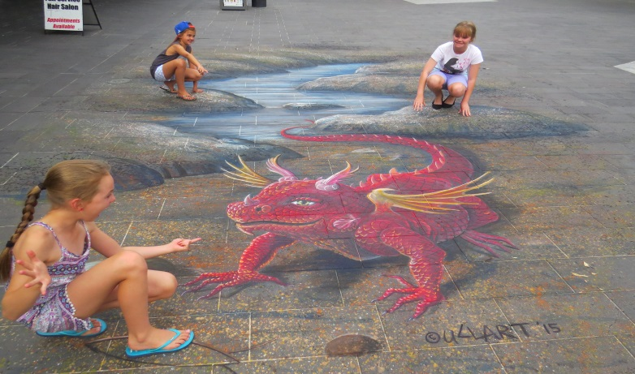

TABLE OF CONTENTS

WELCOME 4

HARGREAVES MALL KEY CONTACTS AND HIRE ENQUIRIES 4

INTRODUCTION 4

1. VENUE DETAILS 5
2. VENUE CAPACITY 5
3. AUDIO EQUIPMENT 6
4. ADVERTISING AND SIGNAGE 6
5. ANIMALS 6
6. CANCELLATION (FOR MAJOR EVENTS) 7
7. COMMUNICATIONS 7
8. COGB OFFICER 7
9. ELECTRICAL INSTALLATIONS AND ON-SITE POWER 7
10. Emergencey Services 8
11. Entertainment 8
12. EVENT MANAGEMENT PLAN 8
13. FILM AND PHOTO SHOOTS 8
14. FIREWORKS, CHINESE FIRECRACKERS AND THEATRICAL FIREWORKS 8
15. FOOD AND CATERING 9
16. FULL PAYMENT 9
17. INDEMNITY CLAUSE 9
18. LIGHTING 9
19. LIQUOR LICENSING 9
20. LOGISTICS (BUMP INS/OUTS), REHEARSALS AND TECHNICAL CHECKS 10
21. MARKETING MATERIAL 10
22. MOTORED VEHICLES ON SITE 10
23. MUSIC LICENSING 10
24. PARKING 10
25. PERMITS AND FEES 11
26. PUBLIC AND PRODUCTS LIABILITY INSURANCE 11
27. ROAD CLOSURES 11
28. SALE OF GOODS 11
29. SECURITY AND CROWD CONTROL 12
30. SMOKING 12
31. STAGE AREA 12
32. SUB-LETTING 12
33. TEMPORARY STRUCTURES 12
34. TOILETS 13
35. TRAFFIC MANAGEMENT 13
36. WASTE MANAGEMENT 13
37. WATER ACCESS 14
38. APPENDICES 14

Appendix 1: Site Map ii

Appendix 2: Risk Assessment Document……………………………………………..... iii

WELCOME

Welcome to the Hargreaves Mall located in central Bendigo.

Located in the heart of Bendigo's central business district, the Hargreaves Mall is a busy vibrant outdoor shopping mall.

Over 170 metres in length, the Hargreaves Mall provides a number of event spaces including a central pop-up park.

There are sites for marquees, staging and other event structures as well as two central structures featuring retractable awnings and small, rentable commercial tenancies.

Permanent umbrellas and seating, a unique water feature, drinking fountains, a children’s play space and trees are scattered throughout the mall.

HARGREAVES MALL KEY CONTACTS AND HIRE ENQUIRIES

To utilise the Hargreaves Mall for an event or activity, contact the City Centre Public Spaces Activation Officer Michele Bauer:

Phone: 03 5434 6000

Email: [m.bauer@bendigo.vic.gov.au](mailto:m.bauer@bendigo.vic.gov.au)

Postal Address: PO Box 733, Bendigo Vic 3552

INTRODUCTION

The City of Greater Bendigo has compiled the following information to assist event and activity organisers in their use of the Hargreaves Mall. The size and complexity of your event/activity will determine the level of information, permits and other permissions which may be required.

Meeting and consultations may be required throughout the process.

When a booking is made, the City of Greater Bendigo City Centre Public Spaces Activation Officer will assist you in determining the permits and permissions required, and will also assist you to liaise with the relevant City of Greater Bendigo Units and other authorities where necessary. You will have help to manage the site specific issues and provide indicative costs associated with the venue to assist with budgeting.

All bookings will need to be made online at: <https://bookings.bendigo.vic.gov.au/facilities>. Once your event is registered and approved, you will receive a confirmation and an invoice (as applicable) for any fees due.

1. **VENUE DETAILS**

Hargreaves Mall is a public outdoor open space. It is open to general public day and night, however specific areas are available for event and activity bookings.

The Hargreaves Mall is made up of three distinct areas that come under Central, Williamson and Mitchell.

Hargreaves Mall is a versatile space suitable for a range of activities including:

* + Community events and festivals
  + Displays, exhibitions and expos
  + Business/commercial activities such as promotions, samplings, special offers, giveaways, new product displays and launches, product or service demonstrations
  + Markets
  + Concerts and other entertainment
  + Workshops, outdoor films, outdoor classes
  + Special interest activities such as collectables fairs
  + Welcome or cocktail functions for conferences or business
  + Special interest and sporting event functions
  + Exhibitions and travelling shows
  + Filming
  + Ticketed events

Hargreaves Mall may be available for significant charity and fundraising events (at the City of Greater Bendigo's discretion).

1. **VENUE CAPACITY**

The Hargreaves Mall has the following equipment and services:

* The total area within the Hargreaves Mall site is 4,950 meters square (30m wide by approx 170m).
* 6 market umbrellas
* Seating structures – 57 Linear metres plus additional seating at the Bus Waiting Facility
* 7 Permanent rubbish bins 3 public recycle bins
* On-site power: 2 x 3 phase power,10 single phase outlets and 10 x 15 Amp outlets
* Unique water feature and trees scattered throughout
* Light poles and an ambient overhead web of catenary lighting as well as central catenary LED icicle lighting and 9 sets of changing coloured lights.
* Integrated sound system with Nightlife Subscription
* Two central structures with retractable awnings.
* Two potable water pits
* Two sewer points
* 2 Bike racks
* 2 Wayfinder signs either end
* 2 Notice boards for general public use to advertise upcoming City Centre Events not for commercial advertsising/sales

Additional equipment (hire fees to be discussed with hirer):

* 20 meters of white picket fencing
* Staging with Handrails
* 6 Marquees with sandbags
* Chairs
* Tables
* A Frame sign boards
* Misting Fans
* 5 shade umbrellas for turf area

1. **AUDIO EQUIPMENT**

The Mall comes equipped with a full sound system and one radio mic. It can have other mics/mixing systems plugged into it and is controllable.

There is a 24 hour music playlist subscription that runs through the Mall that can be tailored to the event at had upon advanced request.

Music and noise levels are to be restricted to a reasonable level and must comply with the State Environment Protection Policy (Control of Music Noise from Public Premises)

No. N-2.

Noise must not exceed normal background noise when measured at nearest boundary of any residential or commercial property.

Bendigo has a range of suppliers able to provide audio equipment for events and activities at the Hargreaves Mall.

For further information regarding residential, entertainment, transport and traffic noises refer to [www.epa.vic.gov.au/noise](http://www.epa.vic.gov.au/noise)

1. **ADVERTISING AND SIGNAGE**

Permission for signage for the event during set up and running of the event is granted with the event permit.

Permanent advertising in the Hargreaves Mall is not permitted. Where an event or activity is seeking to install temporary advertising of events within the City Centre community members can utilize the Public notice boards (out of date or non-compliant signage will be removed), A-Frames require prior approval from the City of Greater Bendigo. Under the Local Law, permit fees may be applicable.

1. **ANIMALS**

Excluding dogs on leads permission must be obtained from the City of Greater Bendigo prior to bringing animals on to the site.

1. **CANCELLATION**

The City of Greater Bendigo reserves the right to cancel bookings if:

1. Approvals, permits and documentation have not been completed by the hirer within the 2 weeks prior to event timeline.
2. Maintenance or building works are required, or if the venue is not considered safe.
3. In the event of extreme weather or other uncontrollable circumstances.

1. **COMMUNICATIONS PLAN**

Where events have a significant impact on the surrounding area, (as determined by City of Greater Bendigo) a Communications Plan will be required. This Plan will identify how local businesses, residents, government departments and other organisations will be notified of the event. The Plan will include such things as details of newspaper advertising, letter drops or signage. Details will be required of the content of any advertising, public notices, or signage and the dates of distribution or publication.

1. **COGB Officer**

You will be required to liaise with the City of Bendigo Public Activation Officer regarding your event, to ensure all appropriate permits and conditions are met. Some events held at the venue will be required to have a City of Greater Bendigo Event Coordinator in place for the duration or part of the actual event.

This is at the discretion of the City of Greater Bendigo and such requirements will be stated as a specific condition of this hire agreement. Charges may apply.

1. **ELECTRICAL INSTALLATIONS AND ON-SITE POWER**

Under New Electrical Regulations 2009 there is greater emphasis on electrical safety and therefore the use of electrical equipment must be in accordance with the requirements of AS/NZS 3000, AS/NZS 3002:2008 and ASNZS 3760:2003.

Hargreaves Mall has 2 locations with 3 phase and 10 single phase power outlets, also 10 locations with 15 Amp outlets (refer to the Site Map). The City of Greater Bendigo will organise access to power. If additional power is required, permission must be obtained from the City of Greater Bendigo prior to installing temporary power supplies e.g. generators.

Any electrical installations must be done by a trained, qualified and experienced electrician to ensure circuits are not overloaded during the event.

All leads, equipment and appliances must be tested, tagged and comply with all legislative requirements. Electrical cords should not be placed across walkways without the appropriate protection or anywhere they are subject to mechanical damage.

All events with electrical installations must have suitable fire extinguishers present.

1. **EMERGENCY SERVICES**

Depending on the type and size of event, hirers will be required to notify Victoria Police, Fire Rescue Victoria/CFA, Ambulance Victoria and the SES of the event. The authorities, along with the City of Greater Bendigo will be required to provide input into your traffic, emergency management plan or other plans. The City of Greater Bendigo can assist in liaising with the authorities.

1. **ENTERTAINMENT**

Bendigo is home to a wide range of performers and entertainers. The Public Activation Officer can assist with potential entertainment bookings. Any bookings made will be at the hirer’s cost.

1. **EVENT MANAGEMENT PLAN**

Most events and activities will be required to submit a Risk Safety and Emergency Management Plan at least four (4) weeks prior to the event. Sample templates are available from the City of Greater Bendigo.

Depending on the size and scope of the event, a more detailed Risk and Safety Plan may be required by some event/activity organisers. Risk and safety considerations include:

* All volunteers and contractors involved must have an OH&S site induction.
* All contractors must have appropriate insurances, current licenses and registrations.
* A First Aid/Medical Plan may be required including the provision of personnel and a first aid kit.

Events using LP Gas cylinders, flammable fuels, naked flames (including BBQ, cooking equipment, candles), or other fire hazards must have specific fire prevention and safety strategies in place (e.g. fire extinguishers, Fire wardens and fuel storage procedures).

1. **FILM AND PHOTO SHOOTS**

The Hargreaves Mall can be used for filming and photo shoots, however prior permission must be obtained from the City of Greater Bendigo and the filming and photography must be in accordance with its Film Policy.

If you are interested in viewing this policy please refer to Council's website [www.bendigo.vic.gov.au](http://www.bendigo.vic.gov.au/)

1. **FIREWORKS, CHINESE FIRECRACKERS AND THEATRICAL FIREWORKS**

Fireworks or pyrotechnics are not permitted at the Hargreaves Mall.

1. **FOOD AND CATERING**

If catering is required for functions and activities, or food is being sold or consumed from food stalls, food registrations must be obtained from Streatrader <https://streatrader.health.vic.gov.au/>and a SOT (statement of trade) be lodged via your Streatrader account 5 days prior to event.

A list of approved food vendors must be provided at least 2 weeks prior to the event including each vendors Streatrader registration number.

A copy of the vendors Food Act certificate/notification and approved SOT (statement of trade) must be kept at the food stall for the duration of the event and made available for inspection by an authorised officer upon request.

1. **FULL PAYMENT**

Due upon receipt of invoice.

1. **INDEMNITY CLAUSE**

The City of Greater Bendigo shall not be responsible for any form of loss or damage arising from the hiring of the venue and from events or activities being held on Council's facilities.

1. **LIGHTING**

The Hargreaves Mall has permanent lighting situated around the key locations. Additional lighting can be hired if required.

Where additional outdoor lighting is used it must be designed, baffled and located to the satisfaction of the City of Greater Bendigo such that no direct light is emitted outside the boundaries of the Hargreaves Mall.

1. **LIQUOR LICENSING**

The venue is located in Proclaimed Area No 1: Central Business Area and so the consumption of alcohol is banned. If alcohol is to be served at an event, organisers must hold the appropriate Liquor Licence and staff serving alcohol must hold a Responsible Serving of Alcohol Certificate. A Temporary Limited Liquor License can be obtained from the Department of Justice VCGLR (<https://www.vcglr.vic.gov.au/>). Applications must be lodged at least 35 days prior to the event.

When you make an application a copy of your application will be forwarded to Victoria Police and the City of Greater Bendigo for comment.

The sale of alcohol also requires an Activities in a Public Place Permit from City of Greater Bendigo and an exemption to serve alcohol within a proclaimed area.

1. **LOGISTICS (BUMP INS/OUTS), REHEARSALS AND TECHNICAL CHECKS**

The event organiser must notify the City of Greater Bendigo of the time required to set up and dismantle the event. For larger events a schedule may be required to ensure the coordinated movement of vehicles, equipment and people on site.

To assist with safe set up, Hirers will be required to ensure any work areas where equipment/ infrastructure is being set up is barricaded (e.g. bollards, fencing, hazard tape) to separate construction areas from the general public.

1. **MARKETING MATERIAL**

The City of Greater Bendigo can provide its logo or images for use in your event or activities marketing material (approval of the final artwork must be obtained prior to going to print).

1. **MOTOR VEHICLES ON SITE**

If heavy vehicles, trucks, cranes, forklifts or scissor lifts are used on site, prior approval is required from the City of Greater Bendigo. Only licensed operators are permitted and all vehicles must be segregated from pedestrian traffic with a spotter used at all times.

Due to weight restrictions at certain locations in the Hargreaves Mall, approval to park vehicles in certain areas will need to be obtained.

1. **MUSIC LICENSING**

It is the hirer’s responsibility to ensure the appropriate licences are obtained if music is being played and performances are held at the venue.

Music and performance are protected by copyright law and the hirer will be required to obtain a licence from the Australasian Performing Rights Association (APRA) to publicly perform either live or recorded music.

1. **PARKING**

Parking within the Hargreaves Mall is **prohibited** and access is restricted by bollards.

Between 10.00am-6.00pm delivery or courier vehicles may use the Loading Zone located adjacent to Hargreaves Mall in Mitchell Street and Hargreaves Street and also outside the Multi-Storey Car Park in Hargreaves Street.

Cost effective casual paid parking is available in the streets surrounding the Hargreaves Mall such as Williamson, Mitchell and Hargreaves Streets. Various time restrictions apply in these areas and the restrictions operate seven (7) days a week. Motorists are advised to check parking signs prior to leaving their vehicle.

The Multi-Storey Car Park is located in Hargreaves Street (opposite Library) and provides under-cover parking in the heart of the Bendigo City Centre. The car park is located centrally within a short distance to Hargreaves Mall, Rosalind Park and a large variety of retail businesses in Central Bendigo.

The car park is an affordable and convenient place to park, where you can park without time restriction. Patrons only pay for the time used with credit card facilities available. A lift services all levels allowing patrons to park their vehicle, walk to the lift and arrive at ground level in Hargreaves Street.

**Parking in Bendigo on weekends is free although still subject to time restrictions.**

1. **PERMITS AND FEES**

Events being held in the Hargreaves Mall may require a variety of permits from the City of Greater Bendigo and other authorities.

When a booking is made, City of Greater Bendigo Public Space Activation Officer will assist you in the planning and delivery stages of the event and in determining the permits and permissions required. They will assist you to liaise with the relevant Council and other authorities where necessary, will help manage the site specific issues and indicative costs to assist with budgeting.

1. **PUBLIC AND PRODUCTS LIABILITY INSURANCE**

Prior to the commencement of the event the event/activity organiser must provide evidence of Public and Products Liability Insurance (providing a Certificate of Currency 2 weeks prior to the event). Public Liability sum insured must be not less than $10 million for any one event. Some events may require $20 million coverage. The hirer is responsible for their own insurances for items brought into the venue and other relevant insurances associated with their event or activity.

1. **ROAD CLOSURES**

If your event requires roads to be closed in the surrounding streets of the venue, approval from the City of Greater Bendigo, and VicRoads if appropriate, must be sought. This process requires to be commenced at least three (2) months prior to the event taking place.

Be aware that road closures may also affect the bus services so contact with the Department of Transport may be necessary.

1. **SALE OF GOODS**

Offering of goods or services for sale from the venue is not permitted unless the City of Greater Bendigo has granted permission to do so. To sell goods such as food/retail goods or to offer services you must obtain A Local Law Number 5 Permit.

1. **SECURITY AND CROWD CONTROL**

For larger events, the event organiser will need to work with the City of Greater Bendigo and where necessary other relevant authorities, to determine the level of security/crowd control required during the event.

Where security/crowd controllers are being used, the following information is required from the security provider: Certificate of Registration of a Company, Certificate of Registration from the Private Agent’s Registry, Certificate of Work Cover Currency and Public Liability.

1. **SMOKING**

The City of Greater Bendigo encourages event organisers to implement Smoke Free Events within the venue area.

Designated Outdoor Dining Spaces as well as the area 10 metres around the Playspace are smoke free zones.

1. **STAGE**

A stage area is available for temporary staging to be brought onto the site.

If a stage is to be brought on to the site, all stage construction must comply with the relevant sections of the Building Code of Australia and Building Regulations (also see Temporary Structures).

1. **SUB-LETTING**

The hirer may not assign or sub-let the venue or any part thereof to another party.

1. **TEMPORARY STRUCTURES**

Where temporary structures such as marquees, portable seating or stages are used on site, prior permission from the City of Greater Bendigo is required.

A number of temporary structures require a permit from Council and/or the Building Commission. These include:

* Tents, marquees or booths with a floor area greater than 100m2;
* Tiered seating stands for more than 20 persons;
* Stages or platforms (including sky borders and stage wings) exceeding 150m2 in floor area;
* Prefabricated buildings exceeding 100m2 other than ones placed directly on the ground surface.
* Events charging an admission fee and those that are substantially enclosed.

The above marquees, stages and platforms must be registered with the Building Commission (generally by the supplier) and erected by a registered contractor (registered building practitioner or registered as an Erector or Supervisor of Temporary Structures).

Council’s Municipal Building Surveyor will approve the siting of the structures. A planning permit may also be required for some temporary structures.

No temporary structures can be fixed or attached to any fittings or existing structures.

Event organisers must provide Council with evidence of registration and insurance covering the structure and in some cases a Siting Permit must be obtained. Applications for Siting Permits from Council should be made at least six (6) weeks in advance of the event.

Event organisers must ensure the suppliers of the above categories of temporary structures have a valid Occupancy Permit for the structure. When Occupancy Permits are issued, the maximum occupancy numbers will be stated along with a range of other conditions including the provision of fire extinguishers, exits, egress and emergency response plans, safety officers, the number of toilets, wind speed issues and lighting etc.

Siting Permits may be required for some amusement rides. This should be discussed with the Municipal Building Surveyor.

The design and installation of all temporary structures shall be structurally independent and shall prevent damage to pavements and other permanent site features.

1. **TOILETS**

There are no public toilets in the Mall. There are some just over Williamson St near the reject shop and can be asked to stay open late. Or the hirer will need to bring in appropriate amenities.

1. **TRAFFIC MANAGEMENT**

If your event is expected to attract a crowd of more than 500 people, a Traffic Management Plan may be required. The Public Spaces Activation Officer will advise of information that may be required.

1. **WASTE MANAGEMENT**

Waste management services and event bins must be coordinated in advance of the event with the City of Greater Bendigo. The site must be left in a clean and tidy condition during and at the completion of the event/activity.

Where events are likely to attract over 500 people, a Waste Management Plan will be required. The City of Greater Bendigo will work with Hirers to develop the plan and where additional services are required, the City of Greater Bendigo will provide details of costs involved prior to the event.

Other waste services are able to be supplied to the venue by external organisations e.g. recycling services, skips etc.

If additional cleaning is required to be conducted by the City of Greater Bendigo, the hirer may be charged.

1. **WATER ACCESS**

The Hargreaves Mall site has two potable water points available. The City of Greater Bendigo will enable access during events.

1. **APPENDICES**

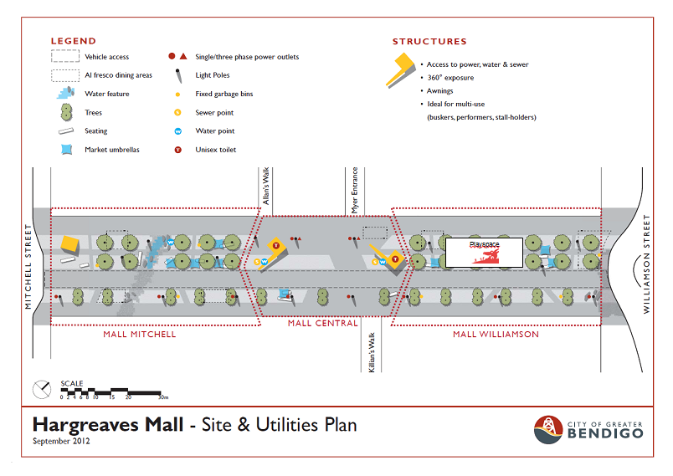

**Appendix B: City of Greater Bendigo Permits and Fees**

|  |  |  |
| --- | --- | --- |
| **Venue Hire Fees** |  | **Responsible Unit** |
| Community Hire | $0 - $150 | COGB |
| Major Events | $2,200 | COGB |
| Commercial | $150 - $500 per day depending on type event. | COGB |
| **Permits** | **Cost** |  |
| Public Liability Insurance (if needed) | $26.50 (for up to 3 days) | COGB |
| Local Law No 5 Event Permit Fee | $0 (Community)  Commercial $78.55 | Local Laws |
| Temporary Food Premises Permit Fee | From $76 depending on type of food/event | Environmental Health |
| Itinerant Trade Permit (one-off/misc) | $50 | Environmental Health |
| POPE (Places of Public Entertainment Occupancy) Permit | $360 - $530 (late fee of less than 4 days for approval $265) | Planning |
| Temporary Structures and Special Use Occupancy Permits | From $165 | Building |
| **Services** |  |  |
| Waste Management Services | As needed per individual event | Waste management |
| Provision of City of Greater Bendigo Event Coordinator on site | As needed per individual event | COGB |
| Staffing | $36.50 - $50 per hour (depending upon type of event) | COGB |
|  |  |  |
| Permits Required from External Organisations |  |  |
| Temporary Limited Liquor Licence | Contact: Victorian Commission for Gambling and Liquor Regulation  <https://www.vcglr.vic.gov.au/> |  |
| Music | Contact: Australasian Performing Rights Association (APRA) or  <https://www.apraamcos.com.au/> |  |
|  | Contact: Phonographic Performance Company of Australia Ltd (PPCA) [www.ppca.com.au](http://www.ppca.com.au) |  |

|  |  |  |  |
| --- | --- | --- | --- |
| Event Organiser: |  | | |
| Event Name: |  |  |  |
| Location of Event: |  |  |  |
| Contact Number: |  | | |
| Person in charge of event: |  | | |
| Risk Assessment completed by |  | | |

Instructions to complete Event Management Risk Assessment Planning Template

|  |
| --- |
| What is an Event Management Risk Assessment Template: This template will assist you in identifying the associated risks as well as document how you plan to control or eliminate the risks  Why do you need one? A good event management plan protects not just yourself, but people, the environment, and everyone’s reputation.  How do I write one? Please complete the below template and print as many of page two as necessary- If you need assistance please contact Risk Management on 5434 6000 |
| An Event Management Plan shall address the following:  1 - Bump-In Plan (what do you need to do to set up the event?)  2 - Record of all activities taking place (amusements ride operators, infrastructure suppliers, stall holders)  3 - Licensing of activities (e.g. Liquor license, fire works, local law permits, noise) 4 - Incident Procedures/ Emergency Plans ( focus on communication especially warning, arrangements include: Wardens / First Aid)  5 - Bump-Out Plan (what do you need to do after the event to return the site to acceptable condition?)  ***Print as many of page two as you need and provide attachments as necessary to support the plan being effective (e.g. maps, photos, procedure, plans, insurances, licenses).*** |

|  |  |  |  |  |  |  |
| --- | --- | --- | --- | --- | --- | --- |
| **Running Sheet**  **Process/Task/Activity**  **What activities are you doing?** | **Risk** | **Risk Description**  **1- What might happen,**  **2- How it might happen? and;**  **3- Why might it happen?** | **Risk Score**  (a risk score captures the likelihood of a consequence)  See below for guidelines | | | **Risk Control/Treatment**  **(Use the Determine Risk Treatment, page three)** |
| **Y**es or **N**o | **C** | **L** | **Given existing controls** |
| **e.g. 3** | **e.g. C** | **e.g. M(13)** |
| *e.g. Birthday Party with Marquee* | *yes* | 1. *Break irrigation pipe* 2. *Pegs* 3. *Pegs too long* | *3* | *C* | *M (13)* | *Sand bags instead of pegs.* |

|  |  |
| --- | --- |
| **Event:** | **Assessed by:** |
| **Location:** | **Approved by *(CoGB Risk Management)*:** |
| **Date(s):** | |

| **Running Sheet**  **Process/Task/Activity**  **What activities are you doing?** | **Risk** | **Risk Description**  **1- What might happen,**  **2- How it might happen? and;**  **3- Why might it happen?** | **Risk Score** | | | **Risk Control/Treatment**  **(Use the Determine Risk Treatment Guide below)** |
| --- | --- | --- | --- | --- | --- | --- |
| **Y**es or **N**o | **C** | **L** | **Given existing controls** |
| **e.g. 3** | **e.g. C** | **e.g. M(13)** |
| **Erecting marquees**  **Setting up trestles and chairs.** | **Yes** | **Injury while erecting marquees, lifting and carrying trestles**  **Marquees may move as they are on a hard surface** | **2** | **D** | **L(5)** | **Erect marquees correctly with experienced assistance, lift and carry trestles in the appropriate manner, a two person lift when required.**  **Ensure marquees are weighted correctly with sandbags** |
| **Vehicle access required in a pedestrian area** | **Yes** | **Pedestrians may be injured by a moving vehicle** | **3** | **d** | **m (9)** | **Always drive at walking pace, following the ‘one way system’ in the Hargreaves Mall (enter from Mitchell St end and exit through Williamson St.) When reversing ensure there is someone to ‘spot’ behind the vehicle for pedestrians** |
| **Sound Equipment Access to power** | **Yes** | **Risk from cables to power source – tripping hazard** | **2** | **D** | **L (5)** | **Cover cables with tape or cable covers to reduce tripping hazard.**  **Equipment must be test/tagged** |  |
| **Stage – set up** | **Yes** | **Injury while lifting or erecting portable stage** | **2** | **D** | **L(5)** | **Lift and carry stage sections with 2 person lift. Assemble stage correctly with experienced assistance. Manage stage use to prevent fall from stage.** |
| **BBQ in the Mall** | **Yes** | **Fire from BBQ**  **Oil splatters on ground** | **1** | **d** | **l(2)** | **BBQ conducted by experienced people with Food Handling experience and appropriate permits**  **Fire extinguisher on hand**  **Drop cloth or drip trays to catch the fat/oil and prevent it from ending up on the paved surface.** |
| **Extreme weather** | **Yes** | **Event affected by extreme weather, heat or cold or rain or electrical storm** | **1** | **E** | **L (1)** | **Extreme weather not forecast at this point. Check weather regularly to monitor need to cancel, decision will be made on the morning of the event.** |
| **Extreme weather** | **Yes** | **Event affected by extreme weather, heat or cold or rain or electrical storm** | **1** | **E** | **L (1)** | **Extreme weather not forecast at this point. Check weather regularly to monitor need to cancel.** |
|  |  |  |  |  |  |  |
|  |  |  |  |  |  |  |

To be used with the Event Management Risk Assessment template

**Risk Description - Describe a cause and effect; or describe contributing factors which give rise to risk.**

*Example:* "If an emergency management arrangement is not in place, people may not be warned and therefore they will be put at risk.”

**Determine Risk Score**

|  |  |  |  |  |  |  |  |
| --- | --- | --- | --- | --- | --- | --- | --- |
|  | | ***Criteria*** | **Consequence (C)** | | | | |
| **1** | **2** | **3** | **4** | **5** |
| **Insignificant** | **Minor** | **Moderate** | **Major** | **Critical** |
| ***Medical***  *(Will someone get hurt?)* | Treatment – immediate with full recovery. | Health Professional – immediate with full recovery. | Short term hospital or convalescence – with full recovery. | Long Term hospital or convalescence with less than full recovery. | Death. |
| ***Damage to Plant/Equipment***  *(Will something get broken?)* | Minor repair | Equipment out of service for 1 day | Equipment out of service for 1 week | Equipment out of service for weeks | Not repairable |
| ***Environmental Impact***  *(Will it damage the Environment?)* | Limited loss of individual plants/animals. | Self repair of ecosystem or landscape in 6 months. | Self repair of ecosystem or landscape in 12 months. | Recovery of ecosystem or landscape with support. | Ecosystem or landscape will not recover. |
| ***Newsworthiness***  *(Might it make the media?)* | Organisation | City | Region | State | Nation |
| **Likelihood (L)** | **A** | **Almost Certain to occur** | **M (11)** | **H ( 16)** | **H (20)** | **VH (23)** | **VH (25)** |
| **B** | **Likely to occur frequently** | **M (7)** | **M (12)** | **H (17)** | **H (21)** | **VH (24)** |
| **C** | **Possible and likely to occur at some time** | **L (4)** | **M (8)** | **M (13)** | **H (18)** | **H (22)** |
| **D** | **Unlikely to occur but could happen** | **L (2)** | **L (5)** | **M (9)** | **M (14)** | **H (19)** |
| **E** | **May occur in rare and unusual circumstances** | **L (1)** | **L (3)** | **L (6)** | **M(10)** | **M (15)** |

**Determine Risk Treatment Guide**

Once the Risk Score has been determined, use the table below to plan and implement treatments based on the following:

|  |  |  |
| --- | --- | --- |
| **Risk Score** | **To reduce the risk, you must** |  |
| VH - Very High | Act immediately to reduce the risk by Elimination, Substitution or Engineering - and support these by administrative controls. | **Reliance on** Procedural and/or Personal Protective Equipment **is** **not acceptable**. |
| H - High | Act soon to reduce the risk by Elimination, Substitution or Engineering and supported by administrative controls. | Procedural or Personal Protective Equipment **must not be** the **permanent** control. |
| M - Medium | Take reasonable steps to reduce the risk until Elimination, Substitution or Engineering controls can be implemented. Procedural or Protective Equipment (PPE) can be put in place. |
| L – Low | Take reasonable steps to reduce or monitor the risk at the source. Permanent controls include Elimination, Substitution, Engineering, Procedural or Personal Protective Equipment. | Procedural or Personal Protective Equipment **may** **be** the **permanent** control. |

MAPS (show on map the following):

Bump in / bump out access :

Public parking :

During event emergency vehicle access:

Insert map/sketch here – e.g. Google map

